Ideation Phase
Empathize & Discover

Date | 29-06-2026
Project Name | Automated Network Request Management
Team ID
Maximum Marks

Empathy Map:
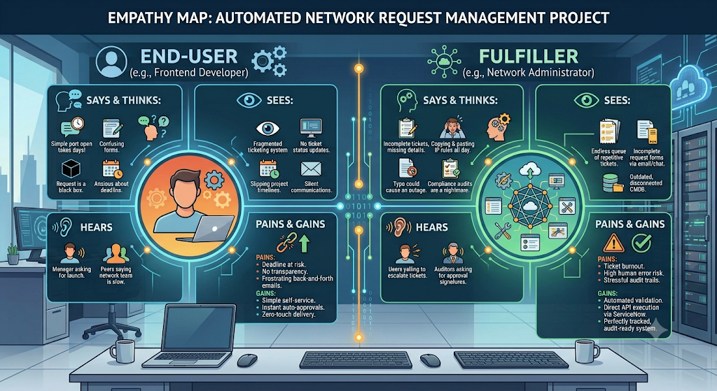

Persona 1: The End-User (e.g., Frontend Developer)

Says & Thinks
- Says: "I just need port 443 open for an API. Why does a simple request take four days and three follow-up emails?"
- Says: "I don't know which form to choose or what technical subnet details they want from me."
- Thinks: “The network team is a black box. I drop my request in, and I have no idea if anyone is even looking at it.”
- Thinks: “This manual process is going to make me miss my deployment deadline.”

Sees
- A fragmented ticketing system with no clear category for specific network requests.
- Radio silence on their ticket status until they manually ping someone on Slack or email.
- Their project timeline slipping due to infrastructure bottlenecks.

Hears
- From Management: "Why isn't the application live yet? We need to hit our launch target."
- From Peers: "Just submit the ticket early, the network team always takes forever to reply."

Persona 2: The Fulfiller (e.g., Network Administrator)

Says & Thinks
- Says: "Half the tickets I get are missing basic information like source IPs or proper business justifications."
- Says: "I spent half my day manually copying and pasting IP rules into firewalls instead of working on our core architecture."
- Thinks: “If I make a typo in this manual configuration, I could accidentally cause a network outage.”
- Thinks: “Preparing for the upcoming compliance audit is going to be a nightmare because our history is scattered across emails.”

Sees
- An endless queue of routine, repetitive tickets piling up daily.
- Incomplete request forms submitted through loose chat messages, emails, and generic tickets.
- An outdated or disconnected CMDB that requires manual updates after every configuration change.

Hears
- From Users: "Can you please escalate this ticket? It’s urgent!"
- From Auditors: "Where is the authorized manager approval signature and validation log for this specific firewall change?"

Pain & Gain Analysis
Category | Details
Pain (Fears, Frustrations, Obstacles) | Deadlines at risk, lack of transparency, and frustrating back-and-forth clarification emails.(Persona 1)  Ticket burnout, high risk of human error from manual entry, and stressful, unorganized audit trails.(Persona 2)
Gain (Wants, Needs, Success Measures) | A simple self-service portal, instant automated approvals for low-risk changes, and zero-touch delivery.(Persona 1)  Automated data validation at intake, direct API-driven execution via ServiceNow, and a perfectly tracked, audit-ready system.(Persona 2)

